COMM 301

Yes/No/Maybe So Angle Argument

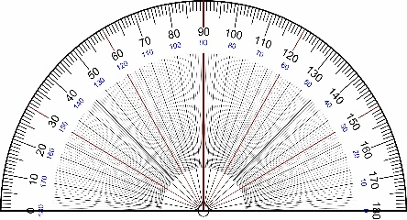

The purpose of this assignment is to practice *developing specific arguments* that fit within larger bodies of knowledge and contexts. It is also designed to *increase your ability to explain an idea* to an audience. Both skills will be helpful when you need to pitch a new idea on the job, especially when you are part of a team—or when you need to add your research to what has already been done. This is an exercise in flexibility as well. Can you be flexible and persuasive in arguing sides of an issue—even if you disagree?

**The Argument**

For this project, you will take a stand on both sides of an organizing question and develop a reasoned, researched argument. You will choose three “angles”—a “yes” stance, a “no” stance, and a “maybe” vision.

The “yes” argues for the question below. The “no” argues against it. The “maybe” is a new idea that modifies or replaces the current situation.

***Organizing Question: Should KU abolish the capstone thesis project?***

**The Format**

This project is a three-part academic argument paper. Each part takes a stance on the question above. Each part should be one page, approximately.

**The Angle**

Your angles should be narrow and specific. They can cover one small aspect of the question.

You need strong reasoning and support for your position. You should do research, interviews, surveys, in addition to using your own ideas, reasons, and knowledge.

1. **The first two angles include both a yes and no to the organizing question.**

For the first two sections of the paper, you will argue both for and against retaining the current system. Here are some ideas:

1. Strengths or weaknesses of current system
2. Time
3. Value or usefulness
4. Professionalism
5. Assessment
6. Reputation
7. Graduation rates
8. Changes in professional fields

These are only a few of the angles you could focus on.

1. **The other angle you need to have is the modification of the current thesis project. The angle describes one idea to replace or modify how KU evaluates graduating seniors.**

For this piece of the paper, you will describe a change, update, modification, or new vision of the current system. You might focus on replacing the thesis, changing it, or adding more options. Describe the vision and argue for its existence using evidence and reasoning.

**The Proposal and Research Plan**

Please plan to propose your main ideas for each section in brief written statement, along with a research plan that describes how you will gather supporting evidence for the project. You will need both primary and secondary research.

**The Assessment**

***Proposal and Research Plan***

* Clear angle or focus
* Specific answer to organizing question
* Organized ideas
* Clear and specific plans for credible research
* Professional style
* Correct grammar and spelling

***Paper***

* Clear angle or focus
* Specific answer to organizing question
* Standard academic paragraphs
* Organized ideas
* Strong reasons
* Valuable support
* Credible primary and secondary research
* Professional style
* Correct grammar and spelling
* APA format
* Reference page